# Design Documentation – Free choice group

# HomeDork – Interactive Smart House

Revision History

|  |  |
| --- | --- |
| **Name** | **Associated Letter** |
| Fanny Söderlund | A |
| Malek Alabed | B |
| Nishat Jahan | C |
| Suzanne Zomer | D |
| Ismail Eyamba | E |

|  |  |  |  |
| --- | --- | --- | --- |
| **Date** | **Version** | **Description** | **Author** |
| 22/09/2021 | 1.0 | Initial discussion of design | A, B, C, D |
| 06/10/2021 | 1.1 | Design of mock lab | A, B, C, D |
| 20/10/2021 | 1.2.0 | Additions of figures 2 and 3 | B |
| 21/10/2021 | 1.2.1 | Addition of D4 and complementing figure 4 | A |
| 23/10/2021 | 1.2.2 | Rearranging text, check spelling and details | A, B, C, D, E |
| 27/10/2021 | 1.3.0 | Grammar revised | E |
| 14/11/2021 | 1.3.1 | Changes in document formatting such as versioning, tables, and titles according to group standards. | A |
| 14/11/2021 | 1.3.2 | Addition of D5, table of figures, and designs related to R1 and R8 | A |
| 15/11/2021 | 1.3.3 | Addition of designs related to R2 and R3 | B, C, D |
| 4/12/2021 | 1.4 | Addition of designs related to R6, R8 and R9 | A, B, C, D, E |
| 6/12/2021 | 1.4.1 | Addition of diagrams and design to R4 | D |

Design item List

|  |  |  |
| --- | --- | --- |
| **Design name** | **Requirements related** | **Priority** |
| D1. Client android app environment | R1, R2, R3 | Essential |
| D2. Client web app environment | R1, R2, R3 | Essential |
| D3. Server/API connection | R2, R4, R5, R6, R8 | Essential |
| D4. Home page designs | R4, R5, R7, R8, R9 | Desirable |
| D5. Settings designs | R1, R2, R3, R6, R10 | Desirable |

Table of figures

Figure 1 - Class diagram of mock client android app 3

Figure 2 - Class diagram of mock client android app 4

Figure 3 - Sequence diagram of connection of the mocked web client 4

Figure 4 - General layout of mocked sever/client interaction 5

Figure 5 - Explainational figures of R4 (Figma, n.d.) 6

Figure 6 -– Design of status commands on the web 7

Figure 7- Class diagram of settings pane with preferences 8

Figure 8 - Use case diagram of haptic vibration 8

Figure 9- State diagram of haptic vibration 9

Figure 10- Class diagram of voice command on Android 9

Figure 11- Use case diagram of voice command on Android 9

Figure 12- Class diagram of voice to text on web 10

Figure 13- State diagram of voice command on Android 10

Figure 14- Class diagram of high contrast on web 10

Figure 15- Class diagram of high contrast on Android 11

Figure 16- Use case diagram of high contrast on web 11

Figure 17- State diagram of high contrast on web 11

Figure 18- Use case diagram of magnifying zoom on Android 12

Figure 19- Class diagram of game 12

Figure 20- Use case diagram of game 13

Figure 21- Class diagram of disco mode on web 13

Figure 22- State diagram of disco mode on web 13

Figure 23- Class diagram of disco mode on Android 14

Figure 24- Use case diagram of disco mode on Andorid 14

Design Item Descriptions

**D1.**

A collection of the designs for the requirements relating to the android client side of the system.

***Mocked environment***

The mocked environment allows the features to be developed encapsulated without outside interaction. The mocked client app is a simple android app that contains the necessary components for the related requirements. The mocked environment is created using Android Studio using mainly Java to integrate easier with the other subgroups. As seen in *figure 1,* the mocked environment aims to be simple with a few components to make it easy for us to develop our features in it.

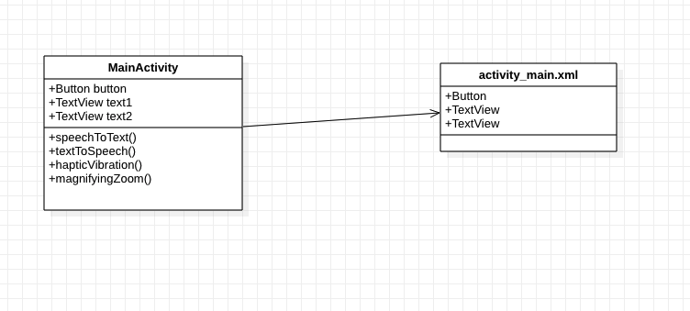

*Figure 1 - Class diagram of mock client android app*

**D2.**

A collection of the designs for the requirements relating to the web client side of the system.

***Mocked environment***

The mocked environment allows the features to be developed encapsulated without outside interaction. The mocked client app is a simple web app that contains the necessary components for the related requirements. *Figure 2* shows the shell of the mock environment of the web client. *Figure 3* shows the connection of the mocked web client to the sever, whether a mocked API call or the actual system server.

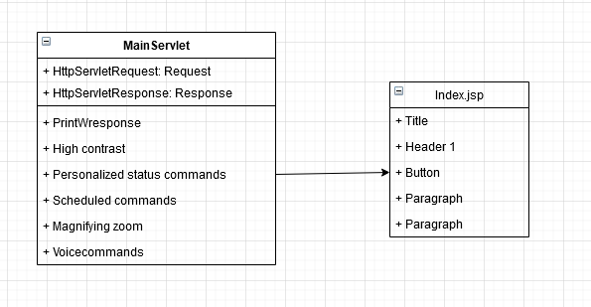

*Figure 2 - Class diagram of mock client android app*

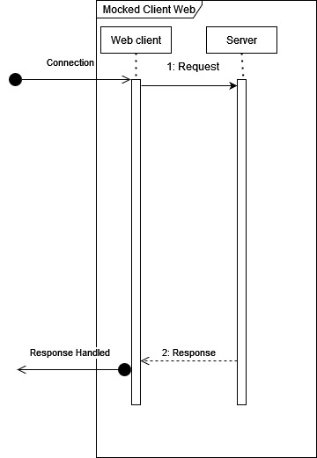

*Figure 3 - Sequence diagram of connection of the mocked web client*

**D3.**

A collection of the designs for the requirements relating to the server of the system. Initially, for testing and developing, the mocked environment will be used, but eventually the implementations will migrate to the actual server/API.

***Mocked environment***

The mocked environment allows the features to be developed and encapsulated without outside interaction. The mocked server allows for testing and implementing of features not yet handled by the current system.



*Figure 4 - General layout of mocked sever/client interaction*

**D4.**

A collection of the designs for the requirements related to the home page, meaning all requirements that are features that the user does not toggle on and off. These features are constant to the system much like the feature to turn on and off different devices.

***R4 – Personalized status commands***

This feature is a home page where the user can set different command buttons that perform different actions set by the user. More is discussed in our requirements document under [R4].

For designing and implementing this feature, following figures (Figure 3) have been made. This is not a definite look of the system, but it gives an understanding of the requirement itself and allows us as a group to explain it better to other subgroups and be clear within the group how the feature should function.

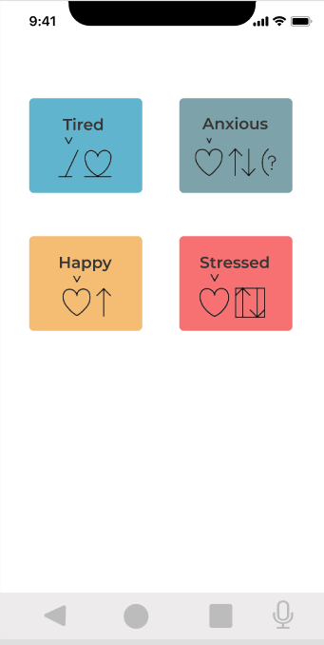 En bild som visar text, iPod, elektronik, skärmbild

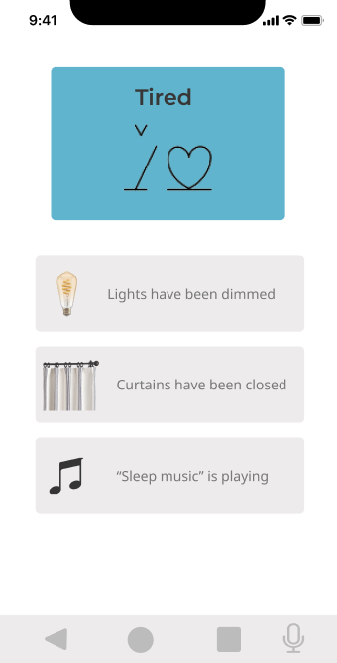

*Figure 5 - Explainational figures of R4 (Figma, n.d.)*

*Figure 6 -– Design of status commands on the web*

*Figure 7 – Class diagram of status commands on the web*

**D5.**

A collection of the designs for the requirements related to the settings panel, meaning all requirements that are features that the user can toggle on and off.

***R1 - Haptic vibration***

Figure 6 shows the class diagram of how the settings pane is related to its xml files for the android client. By using the special “root_preferences.xml” in the xml folder with a PreferencesPane, the changes made in that view will be global to the whole application.

Figure 7 shows a use case diagram of a user turning on and off the setting for haptic vibration.

Figure 8 shows a state diagram of the states the application takes when the haptic vibration setting is turned on or off.

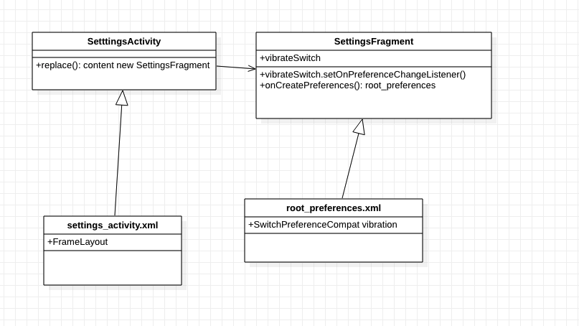

*Figure 7- Class diagram of settings pane with preferences*

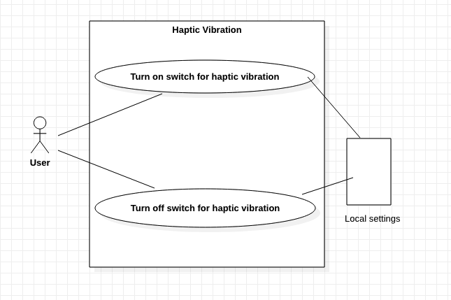

*Figure 8 - Use case diagram of haptic vibration*

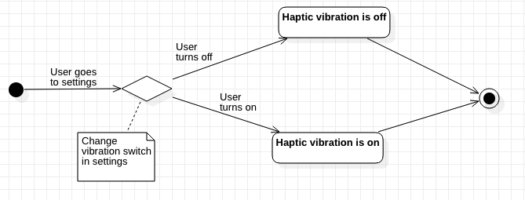

*Figure 9- State diagram of haptic vibration*

***R2 – Voice commands***

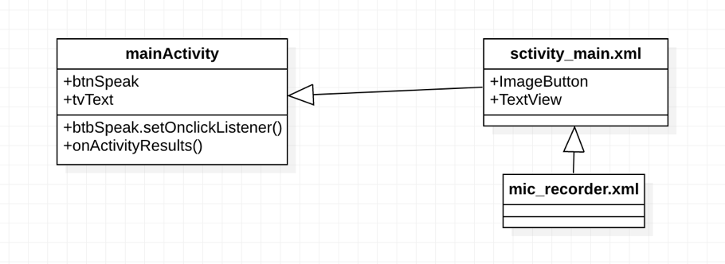

*Figure 10- Class diagram of voice command on Android*

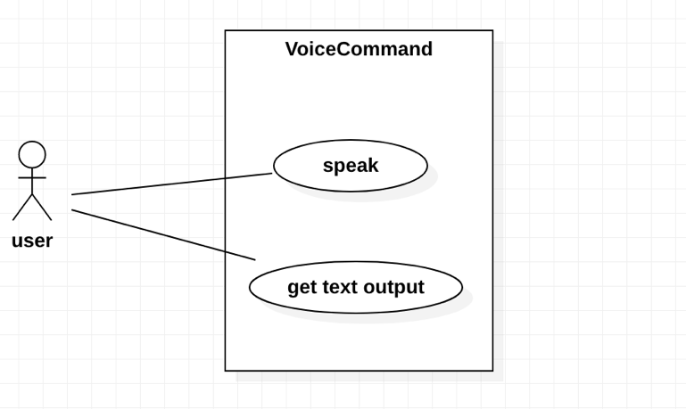

*Figure 11- Use case diagram of voice command on Android*

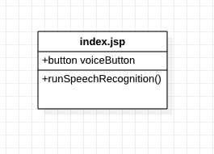

*Figure 12- Class diagram of voice to text on web*

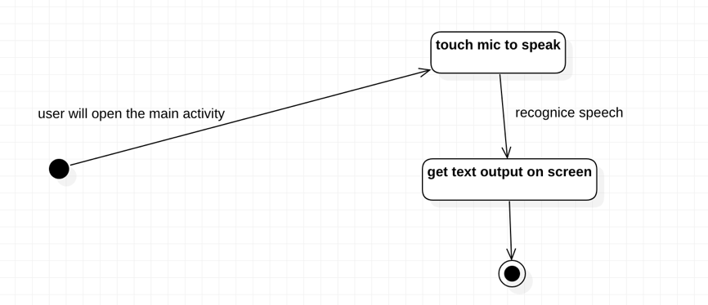

*Figure 13- State diagram of voice command on Android*

***R3 – High contrast***

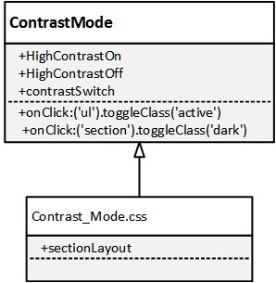

*Figure 14- Class diagram of high contrast on web*

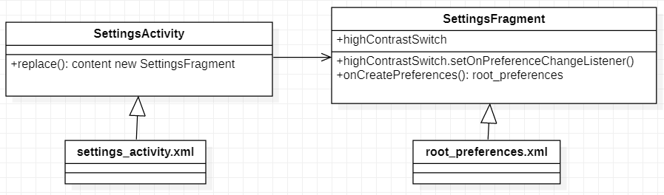

*Figure 15- Class diagram of high contrast on Android*

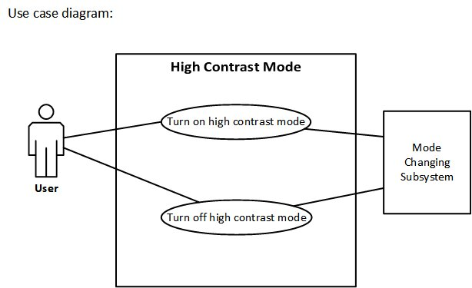

*Figure 16- Use case diagram of high contrast on web*

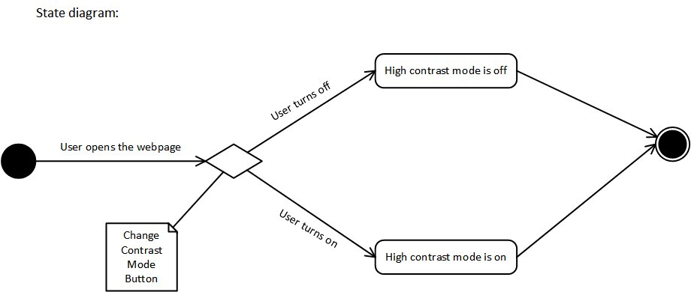

*Figure 17- State diagram of high contrast on web*

***R6 – Magnifying zoom***

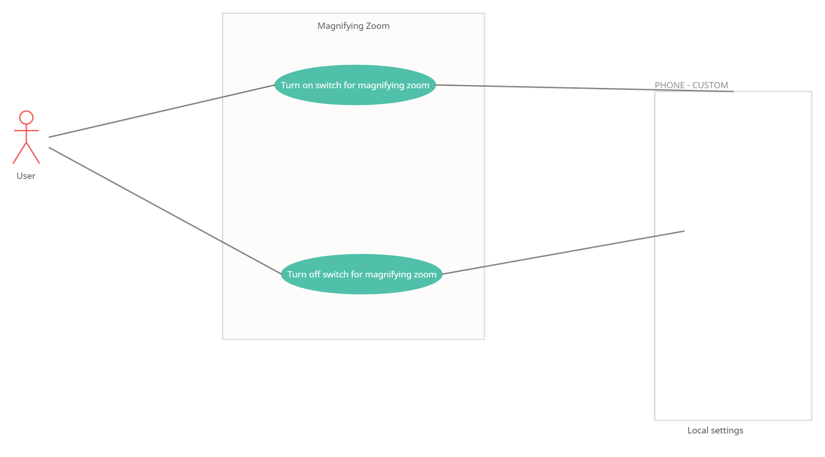

*Figure 18- Use case diagram of magnifying zoom on Android*

***R8 – Game***

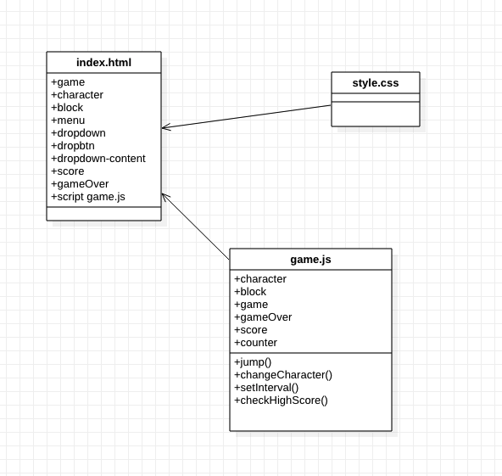

*Figure 19- Class diagram of game*

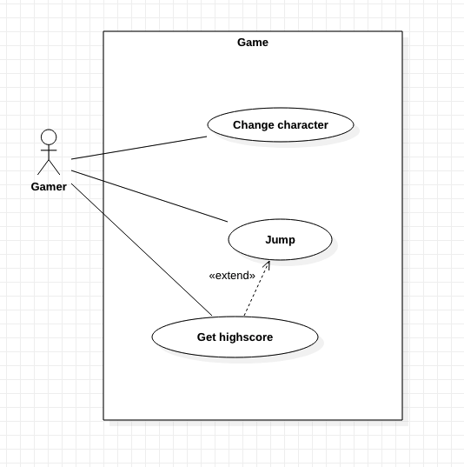

*Figure 20- Use case diagram of game*

***R9 – Disco mode***

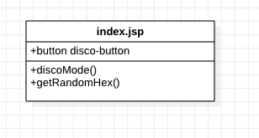

*Figure 21- Class diagram of disco mode on web*

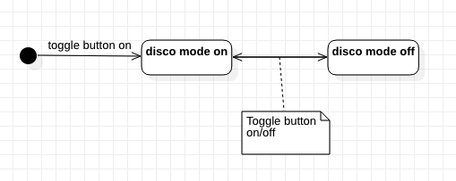

*Figure 22- State diagram of disco mode on web*

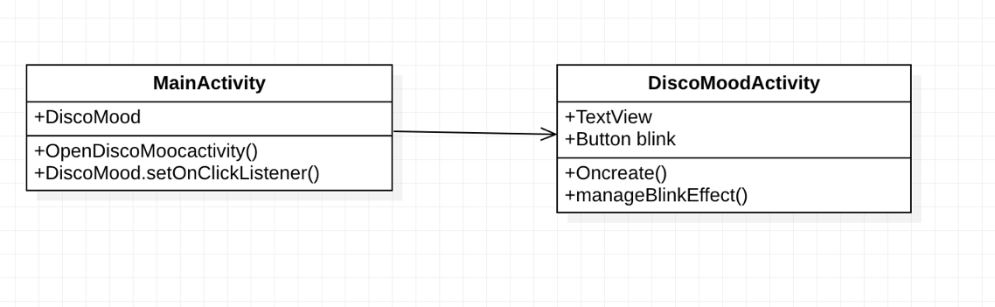

*Figure 23- Class diagram of disco mode on Android*

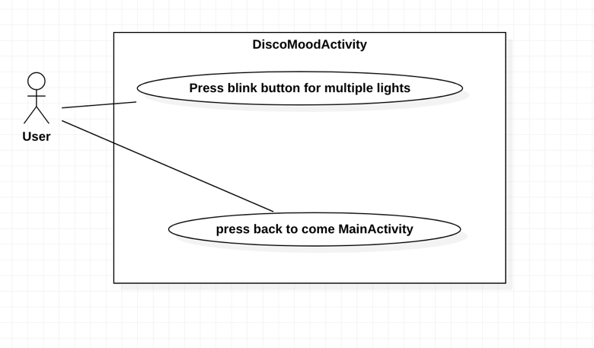

*Figure 24- Use case diagram of disco mode on Andorid*

# Contents

Figma. (u.d.). *Figma* . Hämtat från Figma presentations: https://www.figma.com/proto/qpTRnpeAb3j8zieV8muJEV/Mood-commands?node-id=3%3A360&scaling=min-zoom&page-id=0%3A1